**Header:**

**Database Development Project 6: Transaction Analysis & CRUD Diagram**

Name: Ganesh P Jaishi

Date: 12/4/2023

**Business Synopsis:** This section of the document will focus on one of the three business cases for DBD Sports: the online survey system. The system's primary objective is to engage users with the brand through interactive surveys.

**Business Analysis:** The online survey system is designed to collect user feedback on various topics relevant to DBD Sports' business. The system will handle periodic surveys with different topics and sets of questions.

**Business Rules:**

1. Each survey is associated with a unique topic and has a defined active duration, with start and end dates.
2. Only one survey is displayed on the website at a time to ensure targeted user engagement.
3. Surveys consist of at least 10 questions to ensure comprehensive coverage of the topic.
4. Each question offers a minimum of three choices to provide a range of responses.
5. Participants are required to select one choice per question to complete the survey.

**Additional Assumptions:**

* Multiple surveys can be created but only one can be active at any given time.
* Questions and choices can be updated based on the ongoing requirements of the marketing team.
* Survey responses are recorded without tracking individual user data, focusing solely on the aggregate data for analysis.

**Project 3 EDR Diagram:**

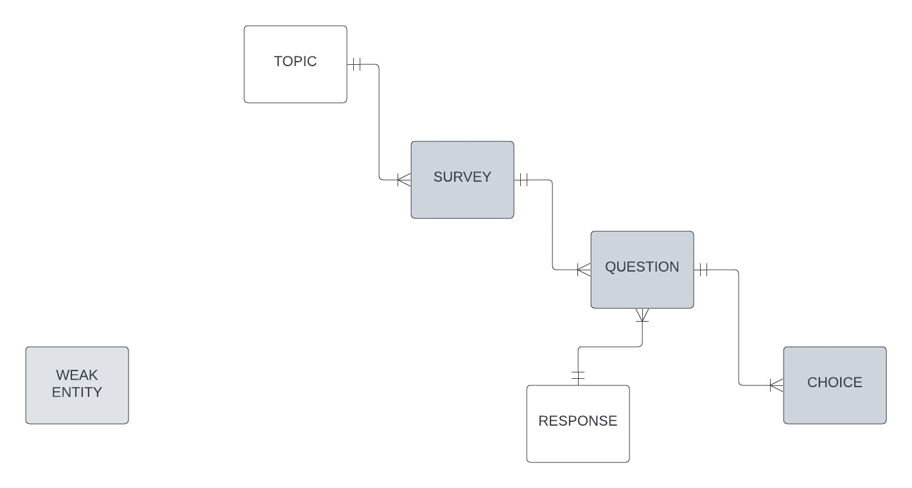

**Transaction Analysis:**

|  |  |  |  |  |  |
| --- | --- | --- | --- | --- | --- |
|  |  |  | TOPIC |  |  |
|  |  | C | A new survey is introduced. |  |  |
|  |  | R | Retrieve details of the active survey. |  |  |
|  |  | U | Update survey details (e.g., end date). |  |  |
|  |  | D | A survey is removed or archived. |  |  |
|  |  |  | QUESTION AND RESPONSE |  |  |
|  |  | C | A user responds to a question. |  |  |
|  |  | R | Retrieve responses for the given question. |  |  |
|  |  | U | Update specific response. |  |  |
|  |  | D | Remove a response if necessary (e.g., during data cleaning). |  |  |
|  |  |  | SURVEY |  |  |
|  |  | C | Introduce new questions for a survey. |  |  |
|  |  | R | Retrieve questions for a given survey. |  |  |
|  |  | U | Update topic details & question text. |  |  |
|  |  | D | Remove a topic or an inappropriate question. |  |  |
|  |  |  | CHOICE |  |  |
|  |  | C | Add new choices for a given question. |  |  |
|  |  | R | Retrieve choices for a given question. |  |  |
|  |  | U | Update choice text. |  |  |
|  |  | D | Remove an invalid choice. |  |  |

**Crud Diagram:**

|  |  |  |  |  |  |
| --- | --- | --- | --- | --- | --- |
|  | **SURVEY** | **RESPONSE** | **TOPIC** | **QUESTION** | **CHOICE** |
| C | RC |  | C |  |  |
| R | R |  | R |  |  |
| U | RU | U | RU | U |  |
| D | RD |  | RD | D |  |
|  |  |  |  |  |  |
| C |  |  |  | C |  |
| R |  |  |  | R |  |
| U |  |  |  | U |  |
| D |  |  |  | D |  |
|  |  |  |  |  |  |
| C |  |  |  |  | C |
| R |  |  |  |  | R |
| U |  |  |  |  | U |
| D |  |  |  |  | D |
|  |  |  |  |  |  |
| C |  | C |  |  |  |
| R |  | R |  |  |  |
| U |  | U |  |  |  |
| D |  | D |  |  |  |

|  |  |  |  |  |  |  |  |  |
| --- | --- | --- | --- | --- | --- | --- | --- | --- |
|  | **SURVEY** | **RESPONSE** | **TOPIC** | **QUESTION** | **CHOICE** |  | **Transaction (ANALYSIS)** |  |
| C | RC |  | C |  |  |  | A new survey is introduced. |  |
| R | R |  | R |  |  |  | Retrieve details of the active survey. |  |
| U | RU | U | RU | U |  |  | Update survey details (e.g., end date). |  |
| D | RD |  | RD | D |  |  | A survey is removed or archived. |  |
|  |  |  |  |  |  |  |  |  |
| C |  |  |  | C |  |  | Introduce new questions for a survey. |  |
| R |  |  |  | R |  |  | Retrieve questions for a given survey. |  |
| U |  |  |  | U |  |  | Update topic details & question text. |  |
| D |  |  |  | D |  |  | Remove a topic or an inappropriate question. |  |
|  |  |  |  |  |  |  |  |  |
| C |  |  |  |  | C |  | Add new choices for a given question. |  |
| R |  |  |  |  | R |  | Retrieve choices for a given question. |  |
| U |  |  |  |  | U |  | Update choice text. |  |
| D |  |  |  |  | D |  | Remove an invalid choice. |  |
|  |  |  |  |  |  |  |  |  |
| C |  | C |  |  |  |  | A user responds to a question. |  |
| R |  | R |  |  |  |  | Retrieve responses for the given question. |  |
| U |  | U |  |  |  |  | Update specific response. |  |
| D |  | D |  |  |  |  | Remove a response if necessary (e.g., during data cleaning). |  |